

MES Traceability Solution

Microtek International Pvt. Ltd.

Software Requirement Specification (SRS)
Project ID:
BAR CODE INDIA, 145 Udyog Vihar Phase 1, Gurugram, Haryana-122016, PH: 0124 4337555

Prepared By: Leena
Submission Date:
Version: 1.0
The document details the summary of solution architecture and approach for the development of MES Traceability Solution for Microtek. The document is based on the inputs, system study, discussions and meeting held between BCI & Haldiram’sTeams.

REVISION NO. | DATE | PREPARED BY | REVIEWED BY | COMMENT
1.0.0 | 1 | Leena |  | Software Requirement Specification Document on basis of detailed process discussion with Microtek.

Abbreviations Used:

Notice:
This document contains information, which is the proprietary property of Bar Code India. This document is received in confidence and its contents cannot be disclosed or copied without the prior written consent of Bar Code India.

Nothing in this document constitutes a guaranty, warranty, or license, express or implied. Bar Code India disclaims all liability for all such guaranties, warranties, and licenses, including but not limited to: Fitness for a particular purpose; merchantability; not infringement of intellectual property or other rights of any third party or of Bar Code India; indemnity; and all others. The reader is advised that third parties can have intellectual property rights that can be relevant to this document and the technologies discussed herein and are advised to seek the advice of competent legal counsel, without obligation of Bar Code India.

Bar Code India retains the right to make changes to this document at any time, without notice. Bar Code India makes no warranty for the use of this document and assumes no responsibility for any errors that can appear in the document nor does it make a commitment to update the information contained herein.

COPYRIGHT
Copyright © BCI 2022. All rights reserved.
TRADEMARKS
*Other product and corporate names may be trademarks of other companies and are used only for explanation and to the owners' benefit, without intent to infringe.

Masters

Material Master
Module Description | The module will be used to save the Material details received from SAP in database.

Data Fields | - Code  - Description  - QA Status  - Material Type-RM,SF,CON TOL,MTS, SPR, SCP, PSD, ESD, HSD  - Purchase packing  - UOM  - Shelf life (shelf life maintain as per vendor manufacturing date in BCI)  - Pack Size (Maintained in BCI)  - Conversion Factor

Process Steps | - Material Master screen will be visible to authorized personnel only  - BCI application will download Material master data from SAP  - SAP will push material data into database table of BCI  - Downloaded Material Master details will get displayed in data grid on screen  - Material data such as code, description, QA status, Material type, purchase packing UOM, Shelf life, pack size, conversion factor will be displayed from the downloaded data.

Functions | Add, edit/update details of the material as per requirement.

Customer Master
Module Description | The module will be used to save the Customer details received from SAP in database.

Data Fields | - Customer Code  - Name

Process Steps | - Customer Master screen will be visible to authorized personnel only.  - BCI application will download Customer Master data from SAP.  - SAP will push customer data into database table of BCI.  - Downloaded Customer Master details such as Customer Code, Name will get displayed in data grid on screen.

Functions | Add edit/update customer details as per requirement.

Vendor Master

Module Description | The module will be used to save the Vendor details received from SAP in database.

Data Fields | - Vendor Code  - Name

Process Steps | - Vendor Master screen will be visible to authorized personnel only.  - BCI application will download Vendor Master data from SAP.  - SAP will push Vendor data into database table of BCI.  - Downloaded Vendor Master details such as Vendor Code, Name will get displayed in data grid on screen.

Functions | Add edit/update vendor details as per requirement.

Storage Location Master
Module Description | This module will be used to add storage location code, its name and the type of the location to provide unique identification to them.

Data Fields | - Storage Location Code  - Name  - Location Type- Accepted, Rejected.

Process Steps | - Storage Location Master screen will be visible to authorized personnel only.  - BCI application will download Storage Location Master data from SAP.  - SAP will push Location data into database table of BCI.  - Downloaded Storage Location Master details such as Storage Location Code, Name, Types such as Accepted (in stock) or Rejected will get displayed in data grid on screen.

Functions | Add edit/update location details as per requirement.

BOM Master
Module Description | The module will be used to save the Bill of Material details received from SAP in database.

Data Fields | - Product Version  - Alternate BOM (Master data)

Process Steps | - BOM Master screen will be visible to authorized personnel only  - BCI application will download BOM Master data from SAP  - SAP will push material data into database table of BCI  - Downloaded BOM Master details will get displayed in data grid on screen

Functions | Add edit/update BOM details as per requirement.

Routing Master
Module Description | The module will be used to save the Routing details.

Data Fields | - Labour  - Machine  - Fuel-Electricity

Process Steps

Functions

Bin Master
Module Description | The module will be used to save the Bin details

Data Fields | - ID  - Description

Process Steps | - Enter Bin ID.  - Enter description of the Bin.

Functions | Add edit/update Bin details as per requirement.

Machine Master
Module Description | The module will be used to save the Machine details

Data Fields | - Code  - Description  - Type  - Remark

Process Steps | - Enter code and description of the of the machine  - Select the type of machine  - Enter remark of the machine if any.

Functions | Add edit/update Machine details as per requirement.

Pallet Master

Module Description | The module will be used to save the Pallet details.

Data Fields | - ID  - description

Process Steps | - Enter Pallet ID and its description.

Functions | The module will be used to save the Pallet details.

Identification Operations

Location Marking

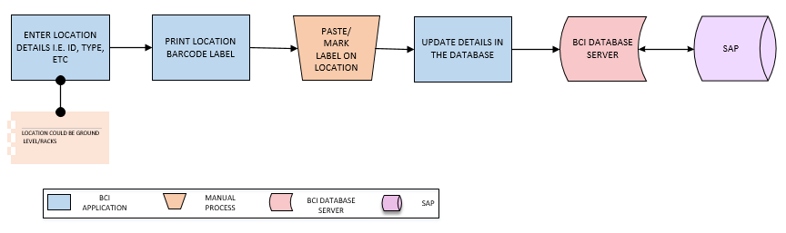
Activities
Module Description | Each location in warehouse will be marked with unique location barcode. This way the exact location of the inventory can be traced at a highly detailed level. The module will help user in Location Label Printing and Marking.

Pre-Conditions | - Location master should be available.  - Location details should be saved in Location master

Process Steps | - Enter Location details such as Location ID, Name, Type, and Description etc.  *Location could be Ground levels/ Racks.  - User will print Location Labels.  - Labels will be pasted on locations.  - Update details in the database.

Post-Conditions | - Location details will get displayed in the database.

Validations | - An alert should be displayed in case duplicate Location data is entered.  - An alert should be displayed in case details are not received from SAP.  - An alert should be displayed in case Location label is not printed.

Bin Identification
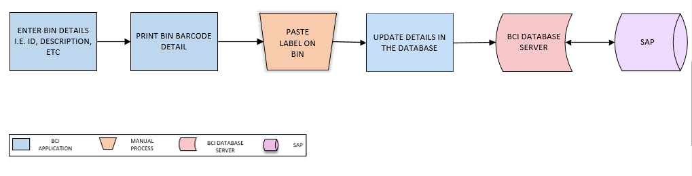
Activities
Module Description | This module will allow user to generate Barcode Label for Bins in order to provide unique identification and to update Bin label printing detail in the database.

Pre-Conditions | - Bin master should be available.  - Bin details should be saved in Bin master.

Process Steps | - Enter Bin details i.e. Bin ID, Description etc.  - Print Bin Barcode Label.  - User will paste label on Bin  - Update details in the database.

Post-Conditions | - Bin details will get displayed in the database.

Validations | - An alert should be displayed in case duplicate Bin data is entered.  - An alert should be displayed in case details are not received from SAP.  - An alert should be displayed in case Bin Barcode label is not printed.

Machine Identification
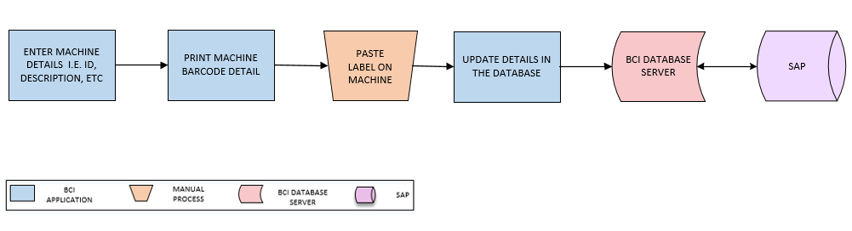
Activities
Module Description | This module will allow user to generate Barcode Label for each Machine in order to provide unique identification and to update label printing details in the database.

Pre-Conditions | - Machine master should be available.  - Machine details should be saved in Machine master.

Process Steps | - Enter Machine details i.e. Machine, ID, Description etc.  - Print Machine Barcode Label.  - User will paste label on respective Machine.  - Update details in the database.

Post-Conditions | - Machine details will get displayed in database.

Validations | - An alert should be displayed in case duplicate Machine data is entered.  - An alert should be displayed in case details are not received from SAP.  - An alert should be displayed in case Machine Barcode label is not printed

Pallet Identification
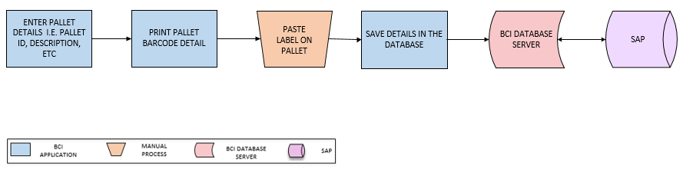
Activities
Module Description | This module will allow user to generate Barcode Label for each Pallet in order to provide unique identification and to update label printing details in the database.

Pre-Conditions | - Pallet master should be available.  - Pallet details should be saved in Pallet master.

Process Steps | - Enter Pallet details i.e. Pallet, ID, Description etc.  - Print Pallet Barcode Label.  - User will paste label on each Pallet.  - Update details in the database.

Post-Conditions | - Pallet will get displayed in the database.

Validations | - An alert should be displayed in case duplicate Pallet data is entered.  - An alert should be displayed in case details are not received from SAP.  - An alert should be displayed in case Pallet Barcode label is not printed

Inventory Replenishment (Bin – Component Mapping)
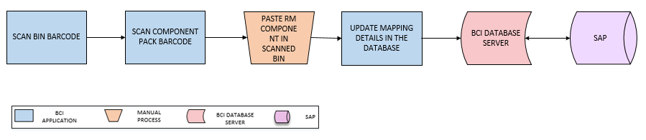
Activities
Module Description | This module will be used to map RM Components with the Bins and details are saved in database. This will help in validating data at the time of Bin issuance to Shop Floor.  Components could be MSL Components.

Pre-Conditions | - Bin master should be available.  - RM component should be available.

Process Steps | - Scan Bin Barcode Label.  - Scan Component Pack Barcode Label.  - User will place Component pack in scanned Bin.  - Update Bin – Component mapping details in the database.

Post-Conditions | - Mapping details will get displayed in the database.

Validations | - An alert should be displayed in case duplicate Bin data is updated.  - An alert should be displayed in case details are not received from SAP.  - An alert should be displayed in case Bin Barcode label is not printed.

Stencil Inventory
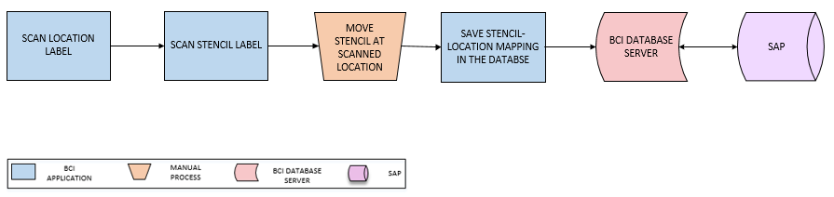
Activities
Module Description | This module will help user in keep track and record the Stencil used for Solder Paste Printing process. Stencil will be mapped with a storage location to keep record of the Stencil inventory.

Pre-Conditions | - Storage Location master should be available

Process Steps | - Scan Location Label  - Scan Stencil Label.  - Move/ store stencil at scanned location  - Update Stencil – Location mapping detail in the database.

Post-Conditions | - Stencil mapping location will get displayed in the database.

Validations | - An alert should be displayed in case duplicate location data is updated.  - An alert should be displayed in case details are not received from SAP.  - An alert should be displayed in case Stencil label is not printed.

FG Warehouse Operation

Receiving
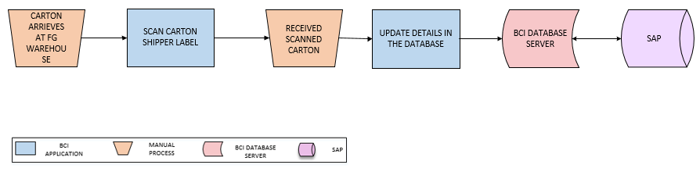
Activities
Module Description | This module will let user to scan & receive Carton from Shop Floor. The inventory details will be updated in the database.

Pre-Conditions | - FG cartons shall be received at FG warehouse.  - Carton Shipper label should be present.  - Pallet shall be available for palletizing cartons.  - All Cartons shall have barcode labels pasted on it.

Process Steps | - Cartons will arrive at FG Warehouse.  - User will scan Carton Shipper Label  - Carton details will be verified and same will be received.  - Update details in the database.

Post-Conditions | - Item Category shall be mapped with Pallet ID.  - Same Item Category Cartons shall be placed on same Pallet.  - Putaway of Pallets should be done.

Validations | - An alert should be displayed in case duplicate/ invalid barcode label is scanned.  - An alert should be displayed in case of invalid activity.  - System shall generate temporary Pallet ID in case Pallet has no barcode label.  - System shall map Pallet ID with item Category of scanned Cartons being placed on it.  - System shall display error message in case different Category Items are being placed on single Pallet.

Putaway
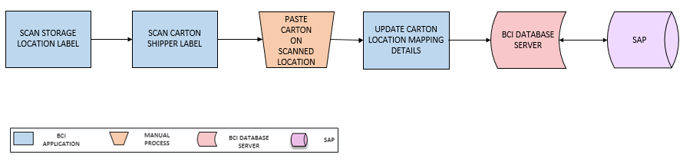
Activities
Module Description | The module will be used to place the FG Cartons on storage location suggested by system based on Location Capacity, Category and Type and to update the Location-Carton mapping details in database.

Pre-Conditions | - Location Label should be printed using the Location Master and tagged.  - Location Code and Location Type should be defined.  - Cartons should have barcode labels.  - Cartons shall be received on pallet.

Process Steps | - User will scan Location and Carton Shipper Label using HHT.  *Location could be Ground level/ Racks.  - User will place the Carton at scanned Location.  - Location – Carton mapping details will be updated in the database.

Post-Conditions | - Location-Cartons mapping will be stored in database.

Validations | - An alert should be displayed in case user scan other location than defined or suggested Location.  - An alert should be displayed in case duplicate / invalid barcode label is scanned  - System shall allow scanning of carton label for putaway in case Pallet Label is available

Picklist Generation
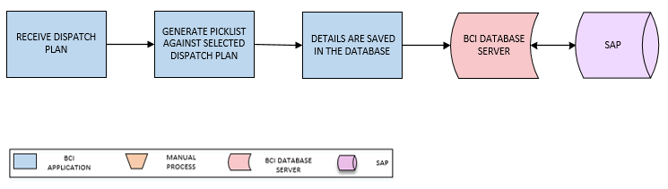
Activities
Module Description | In this process, Picklist will be generated against Dispatch Plan and a unique Picklist ID will be returned. The Dispatch Plan will be fetched from SAP.

Pre-Conditions | - Sales Order shall be received from SAP  - SMTP Host and Server details are required for email configuration  - Route master should be available

Process Steps | - Select Dispatch Plan.  *Dispatch Plan will be received from SAP.  - Generate Picklist against selected Dispatch Plan.  - Update corresponding details in the database

Post-Conditions | - Picklist Number is generated by System

Validations | - An alert should be displayed in case Stock quantity is not available  - An alert should be displayed in case of invalid activity  - System shall check the Stock Quantity against Sales Order Quantity  - System shall allow user to enter more quantity than mentioned in Sales Order for dispatch  - System will not allow user to enter more quantity than Stock available quantity  - System shall generate unique Picklist ID/ Number
Data Required from Microtek | - GET_API will be required to fetch/ pull Dispatch Plan details from SAP and same will be provided by Microtek.

FG Picking
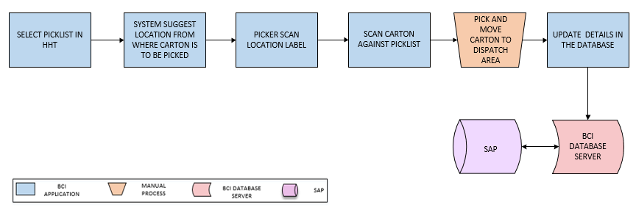
Activities
Module Description | In this process, requested Carton will be picked from the locations suggested by the system. System will verify the Carton against Picklist and details for the same will be updated in database.

Pre-Conditions | - Sales Order shall be received from SAP  - SMTP Host and Server details are required for email configuration  - Route master should be available

Process Steps | - User will select Picklist in HHT.  - System will suggest user about Location from where Carton is to be picked.  - Scan Location Barcode Label against Picklist  - Scan Carton Barcode Label against Picklist.  - User will pick Carton from scanned Location.  - Once picked, warehouse inventory will be updated.

Post-Conditions | - Route is created for Picking

Validations | - System will allow to print Route for material picking  - Single Picklist can be generated for single Sales Order or multiple Sales Orders

FG Dispatch
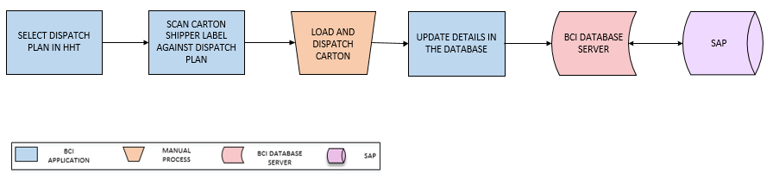
Activities
Module Description | In this process, Carton will be scanned and dispatched against Dispatch Plan and details for the same will get updated in database.

Pre-Conditions | - Picklist should be available.  - Picking should be complete.

Process Steps | - Select Dispatch Plan in HHT.  - Scan Carton Shipper Label.  - User will load and dispatch scanned Carton.  - Update dispatch details in the database.

Post-Conditions | - Transaction details are saved in database.  - Dispatch details shall be posted to SAP.

Validations | - An alert should be displayed in case duplicate/ invalid carton is scanned.  - Once loading is complete, system shall update the Sales Order Status as ‘Dispatched’.
Label Design | Sample Barcode label design for FG operation is given below:  